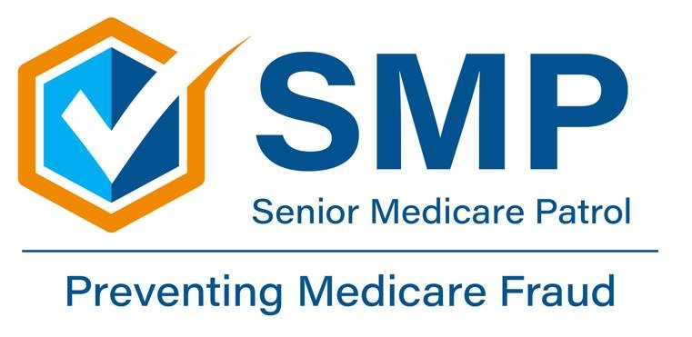

You have contacted the Massachusetts Senior Medicare Patrol (SMP) Program for assistance regarding a health care error, fraud, or abuse issue. Please complete and sign this Release of Information Authorization form so that we may handle your request or refer it to the proper investigative agency if necessary. You are not required to sign the release; however, without your signed consent we cannot send your concern to the appropriate agency for further investigation.
Release of Information Authorization
I, _________________________________________ hereby authorize Lucilia Prates-Ramos or any other Massachusetts SMP Patrol Program representative to discuss my complaint with the appropriate authorities for the purpose of investigating and resolving possible error, fraud or abuse.
I understand that, except for actions already taken, I may revoke this authorization at any time. I also understand that a photocopy of this authorization has the same effect as the original.

_____________________________________________ ___________________
Your signature Date
Please return this form to:
Lucilia Prates, Director
Massachusetts SMP Patrol Program
AgeSpan
280 Merrimack Street, Suite 400
Lawrence, MA 01843
LPrates@AgeSpan.org

This document is supported in part through a grant from the U.S. Department of Health and Human Services Administration on Aging. Grantees undertaking project under government sponsorship are encouraged to express freely their findings and conclusions. Points of view or opinions do not, therefore, necessarily represent official Administration on Aging positions.

Massachusetts Senior Medicare Program ● AgeSpan, ● 280 Merrimack St., Suite 400 ● Lawrence, MA 01843

